IRB Application Protocol

Bellevue University’s Internal Institutional Review Board (I-IRB) requires researchers to submit an application for approval of data collection prior to conducting new research with human subjects.

Outline of the IRB Application Process

- Complete the BU IRB Ethics Training
- Submit a complete IRB application
- Receive feedback on application from an IRB Reviewer
- Receive IRB approval to conduct research with human subjects

IRB Application Walkthrough

BU IRB Ethics Training

Prior to submitting an IRB application, researchers must go to the IRB website (web.bellevue.edu/irb) and complete BU’s IRB training. The training comprises reading the Belmont Report and then completing the IRB Research Ethics Quiz. The link to the Belmont Report and the quiz can be found under the Training tab on the IRB website. If the researcher provides their information when participating in the quiz, they will automatically receive an email containing their certificate upon passing the quiz. This quiz will also be stored in the university’s I-IRB folder. This certification must be completed before an IRB application will be reviewed.

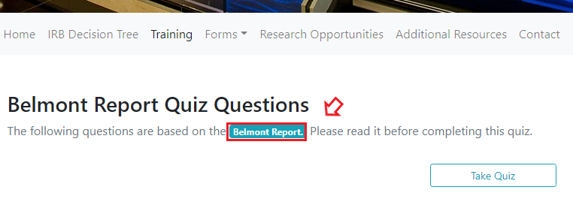
IRB Application

Next, researchers must complete and submit their IRB application form on the website (found under forms).

The following documents must be attached to all complete IRB applications:

- Consent form
- Debriefing form
- All questionnaires and measurements to be used in the study
- Instructions provided to participants



It is strongly recommended that researchers fill out the application in a Word document and then copy their answers to the online form.

Application Review

After the IRB application has been submitted, the IRB chair will review the IRB application and determine whether the application requires an expedited or full board review.

- Expedited review status applications will be assigned to a single IRB member who will either approve, deny, or ask for revisions via email.
- IRB Members will evaluate full board review status applications during the monthly IRB meeting. The board will either approve, deny, ask for revisions, or determine that the application needs to be reviewed by external experts. Any decision will be communicated to the researcher via email.
Application Approval

After the application is approved, the applicant will receive an IRB approval letter from an IRB representative.

